



RHINO

Test Report

Version: 0.2

**Mar 23 2017**

Author: Khanh Vu

Security Classification:**Confidential**

Software Development & Business Process Services

110 Bishopsgate, London

EC2N 4AY

Tel: +44 (0)20 7333 0033

Email: [info@nashtechglobal.com](mailto:info@nashtechglobal.com)



Table of Contents

1. Execute summary 5

1.1 Overview: Project Background and Scope 5

1.2 Scope 5

1.3 Testing Environment 6

2. Execution and Analysis 7

2.1 Performance Test Results and Analysis 7

2.2 Test Run 1 – Baseline Two Hour Load Test 8

2.3 Memory and CPU Utilisation Statistics for severs 10

2.4 Analysis Summary 17

Document History

| Document Location | |
| --- | --- |
| File Name | Location |
| Rhino_Load Test Report.docx | <SVN Folder> |

| Document Version History | | | |
| --- | --- | --- | --- |
| Version | Date | Edited by | Details |
| 0.2 | Mar 23rd, 2017 |  | Create Test Report |
|  |  |  |  |
|  |  |  |  |
|  |  |  |  |
|  |  |  |  |
|  |  |  |  |

Approvers

| Distribution List | | | | |
| --- | --- | --- | --- | --- |
| Name | Role | Signature | Date | Version |
|  |  |  |  |  |
|  |  |  |  |  |

Confidentiality

This document is distributed on a restricted basis, is commercial in confidence to the recipient, and may not be used for any purpose other than that associated with a NashTech project. The contents of this document may not be disclosed to any third parties without the expressed advance written authorisation of NashTech.

# Execute summary

## Overview: Project Background and Scope

Rhino is the software to help owners of small businesses easily manage their work with:

* Clients’ contacts
* Sales proposals
* Projects
* Tasks
* Invoices
* Payment
* Administrative configurations like user management, project types, expense types, system settings, system appearance, etc.

Supported sectors in this application include:

* Construction
* Professional, Scientific & Technical Services:
* Administration & Support Services

## Scope

| Groups | Functions | Percentage (%) |
| --- | --- | --- |
| Normal users | Home | 100 |
| Login |
| Add Contact |
| Save Contact |
| Add Note for contact |
| Save Note for contact |
| Edit Note for contact |
| Delete Note for contact |
| Add Reminder for contact |
| Save Reminder for contact |
| Edit Reminder for contact |
| Delete Reminder for contact |
| Edit Contact |
| Delete Contact |

## Testing Environment

### Hardware / Operating system

According to the current plan, we have the following machines.

| Hardware | Operating System | Description |
| --- | --- | --- |
| 1 Test PC | Standard Harvey Nash system | It is using for implementing test script |
| 1 Web servers | RHE-IRE-APP-LT1 Windows Server 2012 R2 Standard 64-bit  Hardware: CPU Xeon E5-2676 v3 2.4GHz , 2 virtual processors  Memory: 8.00 GB RAM | It is using for hosting the web server.  Testing team must have permission to monitor the hardware usage of the test servers while testing |
| 1 DB Server | RHN-IRE-SQL-LT1 Windows Server 2012 R2 Standard 64-bit  Hardware: CPU Xeon E5-2676 v3 2.4GHz  Memory: 8.00 GB RAM | It is using for hosting the database.  Testing team must have permission to monitor the hardware usage of the test servers while testing |

*The Servers setup and the load generation will be at RHINO environment. Test server environment separated from production server.

# Execution and Analysis

## Performance Test Results and Analysis

We are using scripts to simulate user behaviour for up to 50 virtual users, to measure response times of the system.

Each request should achieve an acceptable response time while processing.

**Performance Requirement**

Operation

* Login to the App = 3 seconds
* Refreshing a Data List (e.g. a list of Contacts, etc.) = 2 seconds
* Add Operator = 2 seconds
* Edit Operator = 2 seconds
* Save Operation = 2 seconds
* Delete Operation = 2 seconds

**Preparation**

* 30 tenants
* Each has 100 users, 10000 Timesheets, 10000 Expenses, 100 Projects, 200 Tasks, 100 Sale proposals, 200 Lines, 100 Contacts.

However, we still missing Notes/ Reminders data.

*I suggest we need more data for Notes/ Reminders for next run: each tenants has 300 notes (3 notes/1 user – 1 for contact, 1 for sale proposal, 1 for expense) and 300 reminders (3 reminders/ user - 1 for contact, 1 for sale proposal, 1 for expense)*

*Total: 9000 notes and 9000 reminders*

## Test Run 1 – Baseline Two Hour Load Test

* Duration: 20 minutes
* Started: Mar 23, 2017, 3:09:43 PM
* Ended: Mar 23, 2017, 3:31:07 PM

**Observations**

### Request Statistics

This report shows statistics for each request (also known as element label) in the test\

|  |  |  |  |  |  |  |  |  |  |
| --- | --- | --- | --- | --- | --- | --- | --- | --- | --- |
| **Element Label** | **# Samples** | **Avg. Response Time (ms)** | **90% line (ms)** | **95% line (ms)** | **99% line (ms)** | **Min Response Time (ms)** | **Max Response Time (ms)** | **Max Response Time (s)** | **Error Percentage** |
| 1.Visit_Home&Login_page | 597 | 460.36 | 2061 | 3687 | 5027 | 5 | 5494 | 5.494 | 0 |
| 2.Click_Login | 596 | 1931.51 | 4679 | 5355 | 6303 | 737 | 6765 | 6.765 | 0 |
| 3.Visit_Contact_page | 595 | 380.08 | 794 | 2547 | 4655 | 60 | 5115 | 5.115 | 0 |
| 4.Click_Add_Contact | 595 | 219.13 | 146 | 1868 | 4411 | 3 | 4954 | 4.954 | 0 |
| 5.Click_Save_Contact | 577 | 582.31 | 1452 | 1970 | 4843 | 160 | 5361 | 5.361 | 0 |
| 6.Open_Note_Contact | 574 | 353 | 506 | 972 | 5019 | 111 | 5858 | 5.858 | 0 |
| 7.Click_Add_Note_Contact | 574 | 247.02 | 196 | 2177 | 4575 | 3 | 5054 | 5.054 | 0 |
| 8.Click_Save_Note_Contact | 569 | 468.36 | 974 | 1486 | 4815 | 117 | 6037 | 6.037 | 0 |
| 9.Click_Edit_Note_Contact | 569 | 197.84 | 26 | 1900 | 4327 | 1 | 5076 | 5.076 | 0 |
| 10. Update_Note_Contact | 568 | 253.29 | 165 | 446 | 4367 | 50 | 5564 | 5.564 | 0 |
| 11.DELETE_Note_for_a _Contact | 566 | 396.41 | 527 | 2437 | 4791 | 105 | 6041 | 6.041 | 0 |
| 12.Back_to_Contact_page | 565 | 425.49 | 706 | 1235 | 4583 | 148 | 5576 | 5.576 | 0 |
| 13.Open_Reminder_Contact | 563 | 246.71 | 139 | 374 | 4803 | 47 | 5313 | 5.313 | 0 |
| 14.Click_Add_Reminder_Contact | 557 | 537.5 | 1094 | 4219 | 5711 | 73 | 5977 | 5.977 | 0 |
| 15.Click_Save_Reminder_Contact | 557 | 461.35 | 587 | 1307 | 5579 | 107 | 6071 | 6.071 | 0 |
| 16.Click_Edit_Reminder_Contact | 557 | 234.48 | 43 | 2489 | 4093 | 3 | 5047 | 5.047 | 0 |
| 17.Update_reminder_Contact | 557 | 208.48 | 168 | 280 | 4347 | 50 | 5125 | 5.125 | 0 |
| 18.DELETE_Reminder_for_a_Contact | 556 | 362.76 | 399 | 2261 | 4703 | 79 | 5747 | 5.747 | 0 |
| 19.Back_to_Contact_page | 556 | 582.69 | 1304 | 3199 | 4979 | 151 | 5853 | 5.853 | 0 |
| 20.Click_Edit_Contact | 554 | 322.76 | 373 | 3011 | 4819 | 4 | 5044 | 5.044 | 0 |
| 21.Update_Contact | 553 | 368.71 | 622 | 1035 | 4771 | 88 | 5912 | 5.912 | 0 |
| 22.Click_DELETE_Contact | 552 | 224.84 | 404 | 716 | 1070 | 102 | 4269 | 4.269 | 0 |
| **ALL requests** | **12507** | **433.77** | **1016** | **2835** | **5035** | **1** | **6765** | 6.765 | **0** |

**Explanation:**

For example: request ‘Click_Login’,

#Samples: 596 samples

Average Response Time (ms) = ~1931.51ms~1.9s

90% line (ms): 90% samples has response time less than or equal 4679ms ~ 4.7s

95% line (ms): 95% samples has response time less than or equal 5355ms ~5.4

99% line (ms): 99% samples has response time less than or equal 6303ms ~6.3 (mean that <5% of samples met this response time)

Min Response Time (ms): 737ms

Max Response Time (ms): 6765ms~7s

### Errors

No Error displayed during this run.

## Memory and CPU Utilisation Statistics for severs

Start Time: 2017-03-23 08:09 (UTC time)

End Time: 2017-03-23 08:31(UTC time)

### Web App Server:

#### CPU Load

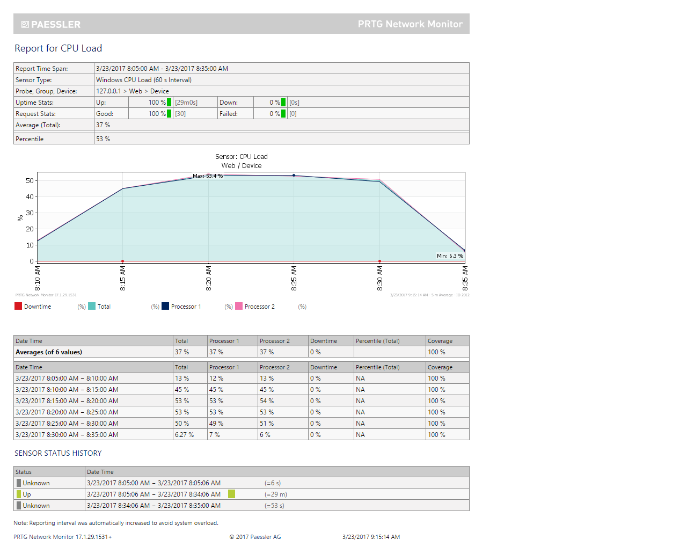

#### Memory

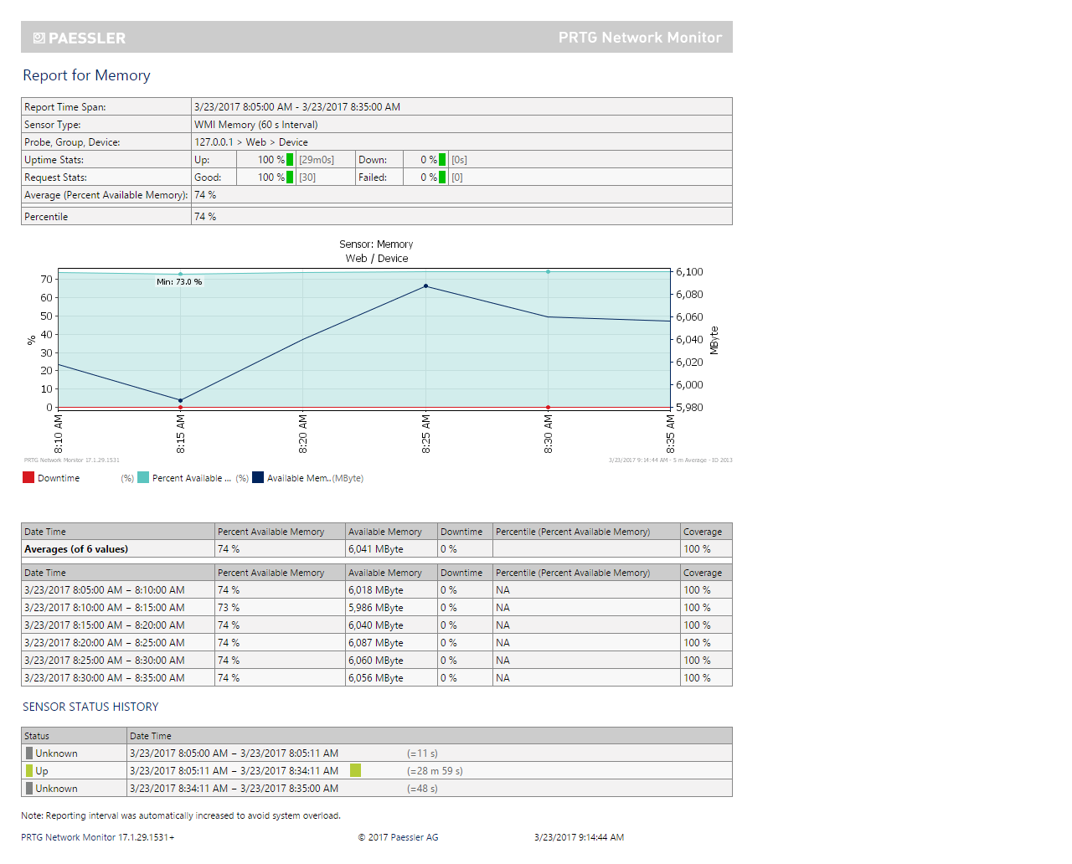

#### Network:

### Database Server:

#### CPU Load

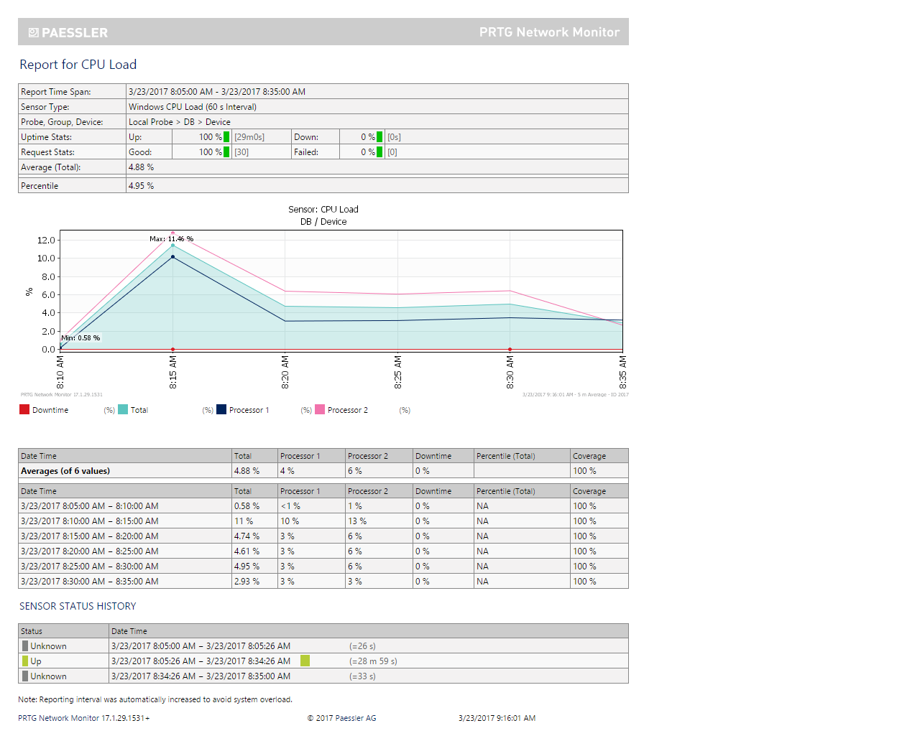

#### Memory

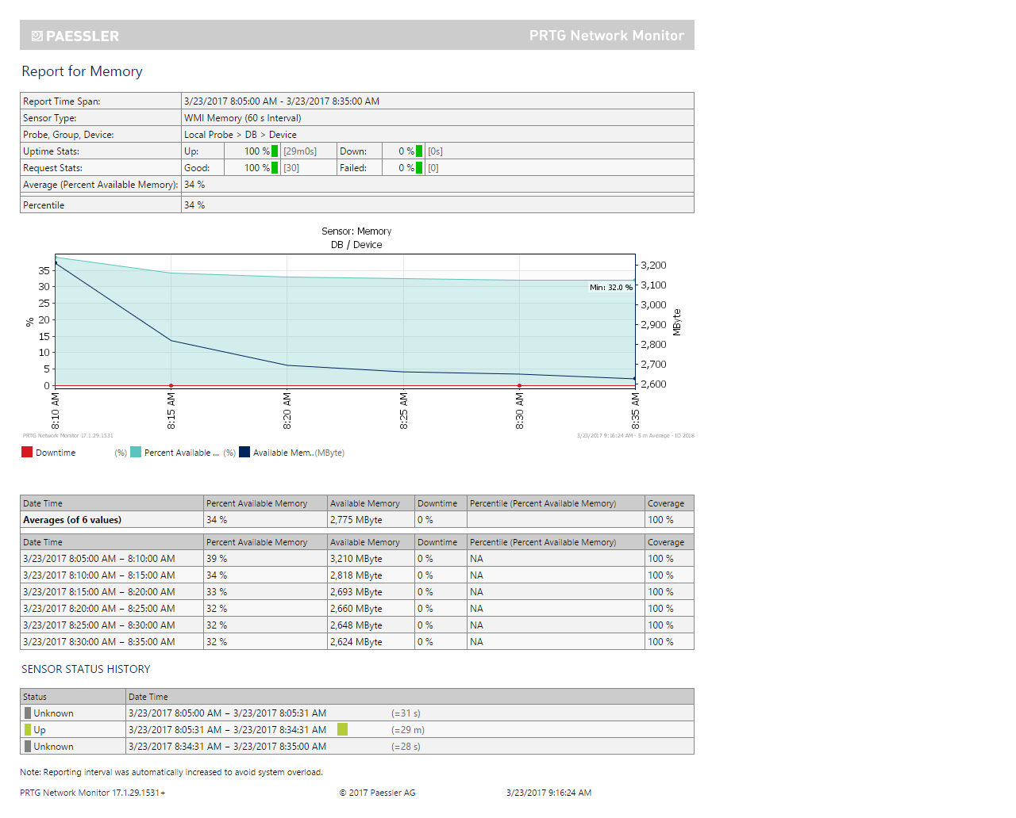

#### Network

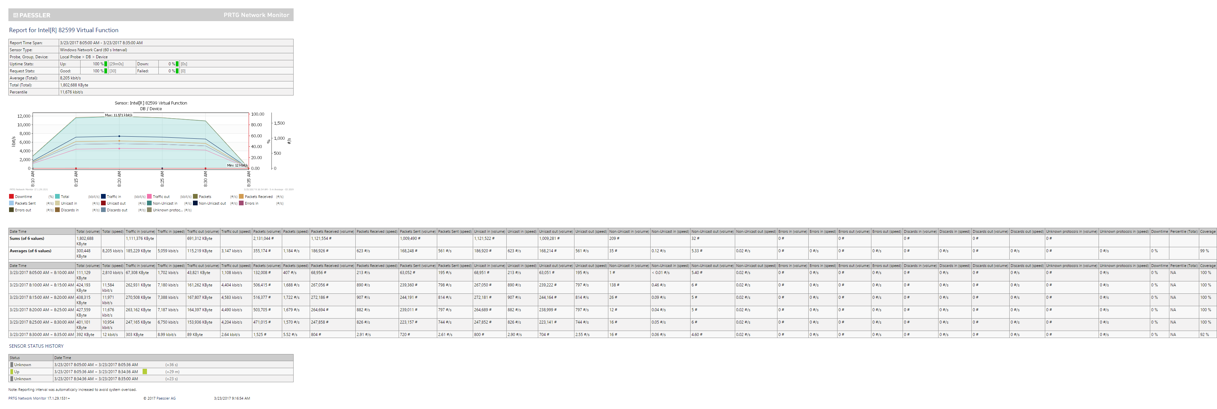

During executing time of these tests, the health of both Web Application & DB Servers was normal.

## Analysis Summary

Test Run 1 is Passed during Performance Test execution. >90% samples with response times that as expected. Some requests (<10% of #samples) to access a page or post/put data have Slow Response Times (in red).

Login request call many API requests (~10 API). That’s why that request always has lowest response time. Some other requests also call several API (example Visit_Contact_page call 3 APIs).